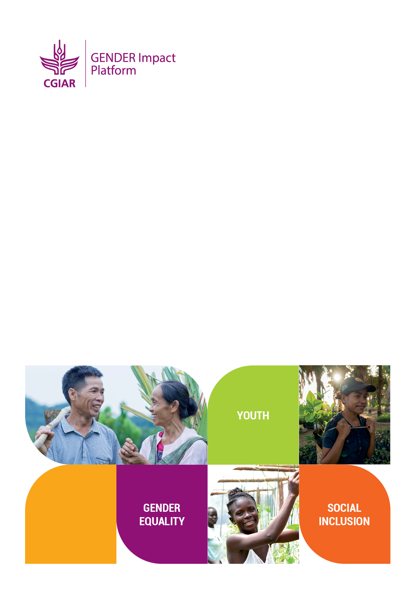

CGIAR Generating Evidence and New Directions for Equitable Results (GENDER) Impact Platform
Methods Module
WEAI-Climate Learning Grants
RESEARCH GRANTS TO INTEGRATE WOMEN’S EMPOWERMENT IN AGRICULTURE INDEX (WEAI) TOOLS IN CGIAR RESEARCH FOCUSED ON CLIMATE CHANGE

Proposal Template

Proposals should be submitted via email to the CGIAR GENDER Impact Platform GenderPlatform@cgiar.org, with a copy to Rachael Mwangi R.Mwangi@cgiar.org and Isidora Markicevic I.Markicevic@cgiar.org, by 11:59 PM US Eastern Time on 21 July 2023. Late submissions will not be accepted.

For any questions about the grant application process, please contact us via email at IFPRI-WEAI@cgiar.org.
Cover Sheet

Project type |  | □ Led by a CGIAR research initiative  □ Bilaterally-funded project led by a CGIAR center
Lead CGIAR research initiative or CGIAR center
Other CGIAR research initiative(s), CGIAR center(s) and partner organization(s)
Geographic location(s) of project
Other funders of project
(if any)
Primary contact | Name
 | Center
 | Title
 | Email
 | Telephone
Date submitted (DD/MM/YYYY)
Submitted by (if different from primary contact): | Name
 | Center
 | Title
 | Email
 | Telephone
Study type (check all that apply) |  | □ Diagnostic study  □ Experimental or quasi-experimental study  □ Validation study
Knowledge gaps identified in project (check all that apply) |  | □ Impacts of climate change programs and/or climate-smart agriculture practices on women’s empowerment  □ How women’s empowerment facilitates the adoption of climate-smart strategies or innovations in agricultural production and along agricultural value chains and/or contributes to improved well-being under climate change  □ Promising interventions or approaches to simultaneously increase women’s empowerment and resilience to climate change
Type of WEAI-related tools (check all that apply) |  | □ Project-level WEAI (pro-WEAI)  □ Pro-WEAI qualitative protocols  □ Pro-WEAI for Market Inclusion (pro-WEAI+MI)  □ Pro-WEAI for Health and Nutrition (pro-WEAI+HN)  □ Women’s Empowerment in Livestock Index (WELI)  □ Women’s Empowerment in Livestock Business Index (WELBI)  □ Project-level Women’s Empowerment in Fisheries and Aquaculture Index (pro-WEFI)  □ Other (specify)___________________
Youth or social inclusion dimensions (check all that apply) |  | □ Youth  □ Social inclusion (specify)____________________
Ethics (IRB) approval  (If not yet approved, indicate where you plan to apply and by when) |  | □ Yes □ Not yet □ N/A

1. Research Proposal Overview

Please refer to the Call for Applications for guidance. Please stay within the specified word limits.

1.1. Research project information
Project Title
Duration of project (months)
Project start date (DD/MM/YYYY)
Project end date
(DD/MM/YYYY)
Total budget (USD)
Principal Investigator(s)

1.2. Project summary including the scope and objectives (max 250 words)

2. Research Proposal Details

Please provide details of your proposed research proposal based on the following criteria. Please stay within the specified word limits.

2.1. Integration of WEAI and climate – complete only one text box depending on your study type

Complete if it is a diagnostic study:
How does the proposed research address key knowledge gaps on gender, agriculture, women’s empowerment, and climate change? How does the proposed research use mixed methodologies? To what extent does the proposed research draw on multiple disciplines? Provide a clear justification of demand or identified need for collecting and analyzing women’s empowerment and climate action to inform project design. (max 400 words)

Complete if it is an experimental/quasi-experimental impact study:
How does the proposed research address key knowledge gaps on gender, agriculture, women’s empowerment, and climate change? How does the proposed research use mixed methodologies? To what extent does the proposed research draw on multiple disciplines? Provide a clear justification of demand or identified need for assessing impacts of climate change interventions, innovations and actions on women’s empowerment in the context of the project. Please state whether the project aim is to Reach, Benefit, or Empower women. (max 400 words)

Complete if it is a validation study:
To what extent does the proposed research present a new and creative approach to collecting, measuring, or analyzing women’s empowerment and climate change data? How does the proposed research address key knowledge gaps on gender, agriculture, women’s empowerment, and climate change? How does the proposed research use mixed methodologies? To what extent does the proposed research draw on multiple disciplines? Provide a clear justification of demand or identified need for the tools or methods being tested and applied. (max 400 words)

2.2. Scientific excellence:

2.2.1. What are your primary research questions and objectives? How does the proposed research build on existing knowledge and add value to existing research in the specified theme? (max 250 words)
2.2.2. What is the planned methodology and analysis plan? Use this space to describe your approach to answering the research questions. Provide a brief summary of how the proposed research will consider intersectionality of gender and other equity considerations that are relevant to the study. (max 250 words)

2.3. Collaboration:

2.3.1. How will the proposed research create strong and equitable partnerships? Please be specific about how your project will support equitable collaboration with partner institutions, including but not limited to project governance, decision-making, work allocation, responsibilities, and resources. (max 250 words)
2.3.2. How will the proposed research add value to other activities undertaken by CGIAR centers or initiatives? (max 250 words)
2.3.3. In what way does the proposed research project reflect interdisciplinary or multi-sectoral expertise? How will the project build research capacity through bringing together senior and early-career investigators? Please be specific about how each team member will contribute their disciplinary perspectives and multi-sectoral expertise to the project. (max 250 words)

3. Indicative Timeline

Complete the below timeline with key activities and outputs. Add more rows as necessary. Please note that the maximum grant duration is 16 months with an estimated start date of 1 September 2023.

Activities and outputs | 2023 |  |  |  | 2024
1.0 | 9 | 10 | 11 | 12 | 1 | 2 | 3 | 4 | 5 | 6 | 7 | 8 | 9 | 10 | 11 | 12
1.1
1.2
etc.
2.0
2.1
2.2
etc.
3.0
3.1
3.2
etc.

4. Indicative Budget

Please provide the total amounts for each heading provided, per participating CGIAR center and partner organization. Add additional rows as necessary.
 | 2023 | 2024 | TOTAL
SALARIES | USD | USD | USD
<center/partner name>
<center/partner name>
DATA COLLECTION | USD | USD | USD
<center/partner name>
<center/partner name>
TRAVEL | USD | USD | USD
<center/partner name>
<center/partner name>
WORKSHOPS | USD | USD | USD
<center/partner name>
<center/partner name>
CONSULTANTS | USD | USD | USD
<center/partner name>
<center/partner name>
DIRECT SUPPLIES | USD | USD | USD
<center/partner name>
<center/partner name>
OTHER DIRECT COSTS | USD | USD | USD
<center/partner name>
<center/partner name>
INDIRECT COSTS | USD | USD | USD
<center/partner name>
<center/partner name>
TOTAL | USD | USD | USD

5. Grant Management

Please stay within the specified word limits.

5.1. Management structure (max 250 words)

Provide details of the management structure for the proposed research project including the key people involved and their roles and responsibilities. Please pay attention to equitable collaborations among centers and researchers.

5.2. Risk management (max 250 words)

Please provide the key risks to the project and the corresponding plans to mitigate them, including the ongoing changes associated with the One CGIAR transition.

6. References (if any)

Appendix 1: CVs of the investigators

Provide the following information for each investigator involved in the project (including principal investigators (PIs), co-investigators, research and project staff and key consultants), beginning with the PI(s). Please do not exceed 1 page per person.

Name | Center/Organization | Title
Role on the project  (Example: PI; Co-I) | Responsibilities on the project  (Example: Responsible for all aspects of the project; Research support for quantitative components, etc.)
Degrees/Diplomas |  | Year conferred
Professional experience (Starting with present position)

Selected publications (Please list up to 5 key publications that are most relevant to the project, including full title, authors, and journal.)

Appendix 2: Statements of support

Please provide a letter of support from the Gender Research Coordinator (GRC) if submitting the proposal from a One CGIAR center. If the GRC is directly involved in the application, the support letter should be provided by the relevant senior management (e.g., Director of Research) from the lead center. For proposals from CGIAR research initiatives, the support letter should be provided by the initiative lead. The letter should demonstrate institutional or initiative’s commitment specifically to the proposed research. Please avoid including general endorsements.

Check out this paper to learn more about the Reach, Benefit, Empower (RBE) framework.

