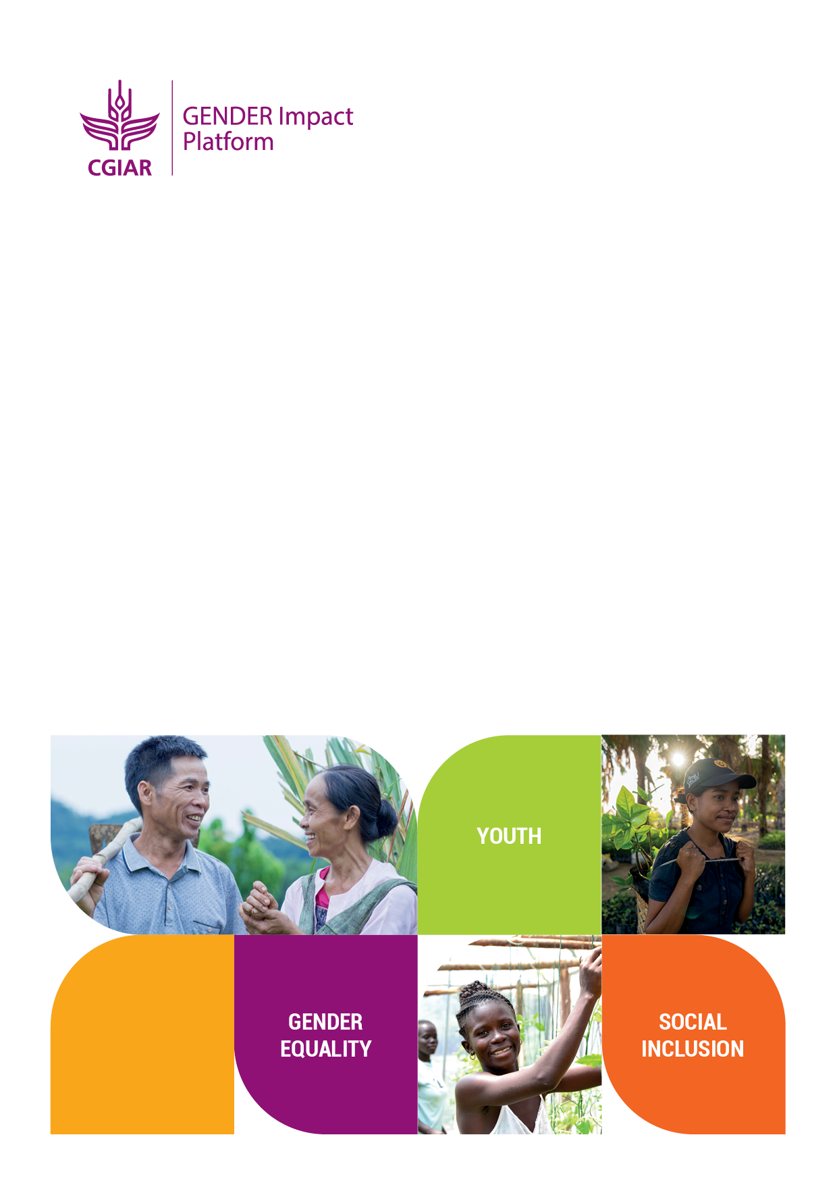

CGIAR Generating Evidence and New Directions for Equitable Results (GENDER) Impact Platform
Evidence Module Research Grant
GENERATE EVIDENCE ON THE TOPIC “WOMEN’S COLLECTIVE ACTION IN AGRI-FOOD SYSTEMS: PROCESSES, OUTCOMES AND LEARNING FROM MENA AND SOUTH ASIA”

Proposal Template

Last updated: 30 June 2023

Proposals should be submitted via email to the CGIAR GENDER Impact Platform GenderPlatform@cgiar.org, with a copy to Rachael Mwangi R.Mwangi@cgiar.org and Isidora Markicevic I.Markicevic@cgiar.org, by 11:59 PM US Eastern Time on 21 July 2023. Late submissions will not be accepted.
For any question about the grant application process, please write to Ranjitha Puskur at r.puskur@irri.org .

Cover Sheet

Title of the Proposal (max 10 words)
Lead applicant
Lead applicant contact details

Lead organization contact details

Project Leader
Please add contact details for the Project Leader if this is different from the lead applicant.

Partners
Countries to be covered
Project dates (MM/YY)
Total budget

GENDER Platform | Other sources of funding (please name source of other funding complementing this research) | TOTAL AMOUNT
 |  | Total:
Total: | Total:

Proposal Narrative
Please refer to the Call for Applications for guidance. Please keep within the word limits.
- Summary of project (500 words)
Please provide a brief summary of your project: the evidence gap it is trying to fill, its aims, main research questions, expected relevance of the evidence for researchers, OneCGIAR initiatives and impact platforms, donors, policy makers and practitioners and, the key activities you plan on undertaking (Max 400 words).
- Project partners
Please list all the CGIAR and non-CGIAR partners that will be involved (including the Lead Organization) and provide a summary of their roles. Indicate names of individuals from the partner organizations who will be involved, roles of each organization, estimated budget split across partners.
Lead Organization name:
Other partners involved and what kind of organizations are they
(CGIAR, INGOs/NGOs/other Non-CGIAR research organizations:
(Max 75 words)
Summary of roles and responsibilities in project:
(max 150 words)
Gender break up of research team who will be involved (F/M/Other)  Please add more rows if required |  | Position F M Other TOTAL  Total

- Relevance of Evidence (Max 400 words)
How will the evidence you generate be used, by whom and what outcomes it can lead to?
·
- Methodology (Max 700 words)
Please summarize the methods and approach you will use to achieve your intended outputs.
Your response needs to include the main research questions, theoretical framing, the design and methods for data collection and analysis, including a description of the variables to be examined and statistical analysis techniques. The section will need to include a strong gender and intersectional analysis throughout the description of the research. It is important that you demonstrate how the proposed research uses mixed methodologies and to what extent does the proposed research draw on multiple disciplines. Provide a description of the interdisciplinary, transdisciplinary, and/or multi-sectoral aspects of the project.

- Previous work (Max 300 words)
Are there any completed or existing projects that the proposed project will build on, or take into account in project design? Please note that we are not just interested in work carried out by the lead organization or partners, but also in the broader practice area. Please list those that you are aware of.
- Planned activities and outputs and project timeline (Max 800 words)
Please summarize the planned activities to be undertaken by the proposed project and the expected outputs: what activities you will undertake and how and when? What are the major milestones and when will they be achieved? What outputs will be produced and when? This should build in sufficient time for review of draft outputs and revisions. Use a table if deemed necessary.
7. Collaboration (Max 700 words)
How will the project create strong and equitable partnerships, particularly with NARES? Please be specific about how the project will support equitable collaboration with partnership institutions, including but not limited to project governance, decision-making, work allocation, responsibilities, and resources (max 300 words).
Does this have any synergies with other activities undertaken by the GENDER Impact Platform and/or to the OneCGIAR initiatives? If yes, which ones and how? How will the proposed research add value to other activities undertaken by the GENDER Platform and/or ONE CGIAR Initiatives? (max 300 words).
8. Capacity strengthening (Max 1000 words)
Please detail the plans for capacity strengthening with a focus on early and mid-career researchers in CGIAR and NARES and other partners.
9. Evidence uptake plan (Max 600 words)
Applicants should summarize their plans for developing knowledge management and communication products, based on evidence generated from the project. Please specify the plans for communicating evidence, uptake, and pathways to impact.

10. Ethics (Max 250 words)
What steps will your team take to ensure that any potential privacy and ethics issues are considered and mitigated? If primary data will be collected, please indicate which IRBs will oversee the ethical review.
How will you ensure that data, publications, and other relevant outputs from your project are findable, accessible, interoperable, and reusable (FAIR)?

Indicative Budget

Please provide the total amounts for each heading provided, per participating CGIAR center and partner organization. Add additional rows as necessary.

A more detailed budget will be required at the contracting stage.
 | 2023 | 2024 | TOTAL
PERSONNEL
<center/partner name>
<center/partner name>
CGIAR collaborators
<center/partner name>
<center/partner name>
non-CGIAR collaborators
<center/partner name>
<center/partner name>
DATA COLLECTION
<center/partner name>
<center/partner name>
TRAVEL
<center/partner name>
<center/partner name>
WORKSHOPS
<center/partner name>
<center/partner name>
CONSULTANTS
<center/partner name>
<center/partner name>
DIRECT SUPPLIES
<center/partner name>
<center/partner name>
OTHER DIRECT COSTS
<center/partner name>
<center/partner name>
INDIRECT COSTS
<center/partner name>
<center/partner name>
TOTAL | USD | USD | USD

Annex 1:
Cover Letter (half a page)

Annex 2:
Letter of support from the Deputy Director-General of the Center (half a page)

Annex 3:
CVs of the researchers

